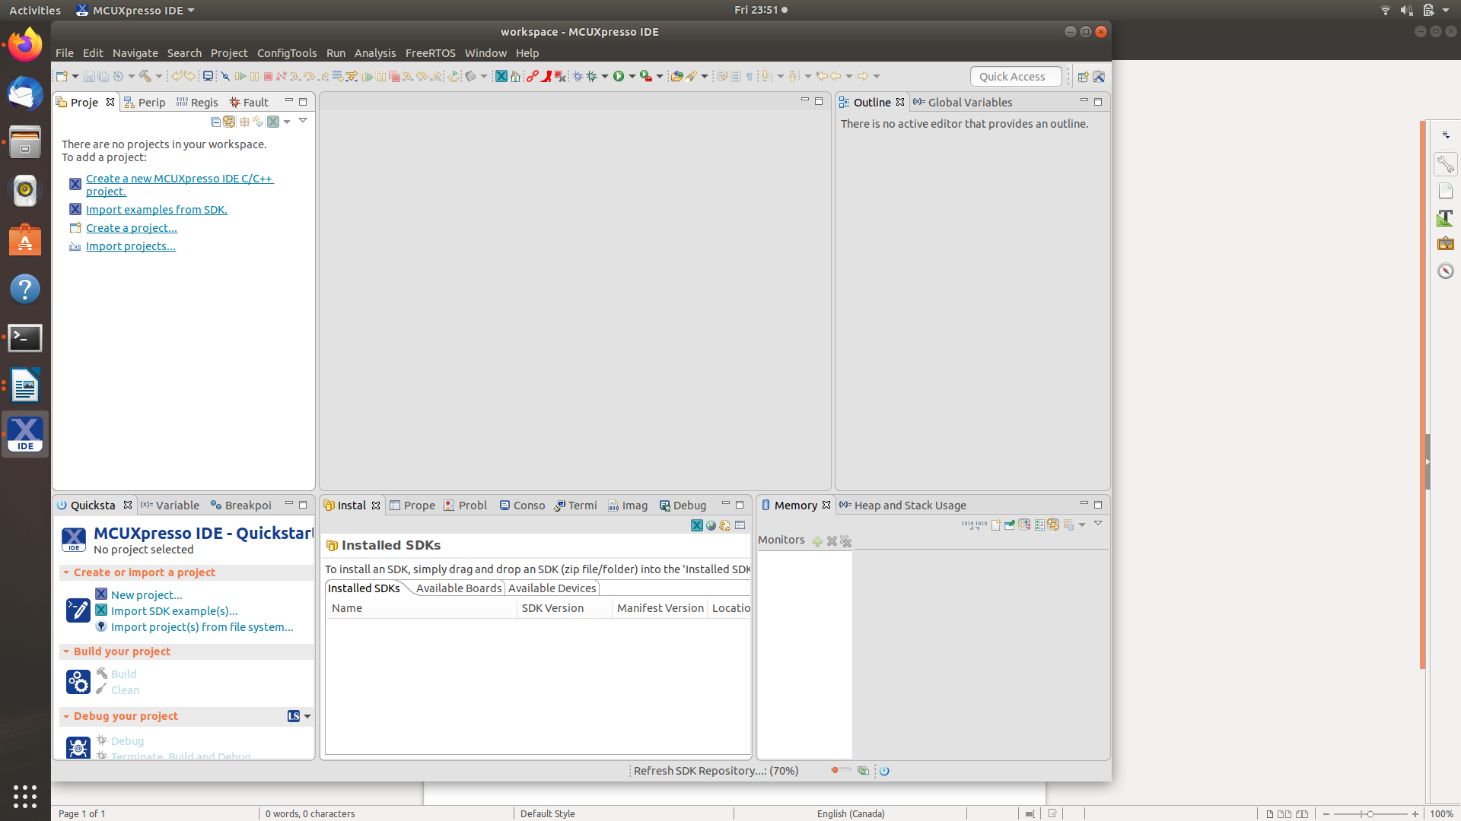
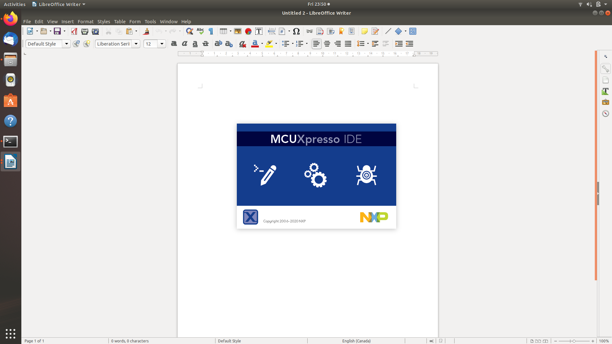
Homework_4

Prepare RTOS Toolchain
******************************************
Download our IDE and cross toolchain from the NXP web site:
https://www.nxp.com/design/software/development-software/mcuxpresso-software-and-tools/mcuxpresso-integrated-development-environment-ide:MCUXpresso-IDE
PLEASE NOTE: You will need to obtain an NXP account in order to perform the download.
Go ahead and read through some of the documentation to familiarize yourself with the tool.
Click on the Downloads tab to save the file into ~/Downloads.
Use the GNU-Linux command "tar" to extract the installer. Change the permissions on the file so that you can run it. Run the file.

